HD 142A

HD 142A is a 1.15 M☉, G1 IV star1, member of a binary system; HD142 B was identified in direct imaging2,3 with a semi-major axis around 150 au and a mass of 0.59 M☉. Based on 82 RV AAT measurements obtained between 1998 and 2011, a study performed in 2012 (hereafter W12)4 reported a giant planet (HD 142Ab) with a period of 349.7 ± 1.2 days, a minimum mass of 1.25 ± 0.15 MJup and an eccentricity of 0.17 ± 0.06 and an additional LPGP (HD 142Ac) with a period of 6005 ± 477 days, a minimum mass of 5.3 ± 0.7 MJup and eccentricity of 0.21 ± 0.07. The CH survey reported only HD 142Ab, with properties close to those reported in the W12 study. Recently, combining 204 AAT RV measurements obtained between 1998 and 2015, 67 HARPS RV measurements obtained between 2004 and 2019, and 35 MIKE RV measurements obtained between 2011 and 2021 with Hipparcos/Gaia absolute astrometry data, a study performed in 20225 (hereafter F22) reported, for HD 142Ab, properties close to those reported in the W12 study and were able to estimate the orbital inclination, and thus the true mass, of HD 142Ac. They found a period of days, an eccentricity of 0.28 ± 0.03, an inclination of °, and a mass of MJup.

In the present study, the F22’s dataset was considered. DPASS and MCMC (1000 walkers, 400000 iterations) were used to fit the data. Using DPASS and MCMC, HD 142Ab was found with properties close to those reported in the W12 study and the orbital parameters of HD 142 Ac were found close to those reported in the F22 study. Yet, as only the RV data were considered, the true mass of the planet could not be determined but only the minimum mass. Using DPASS (resp. MCMC), a minimum mass of 10.4 (reps. 10.4 ± 0.5) Mjup was found.

The fits are shown in Fig 1, the corner plot in Fig 2, and the results are summarized in Table 1.

Conclusion: The properties reported in the CH survey for HD 142Ab are confirmed. The properties found in F22 for HD 142Ac are confirmed.

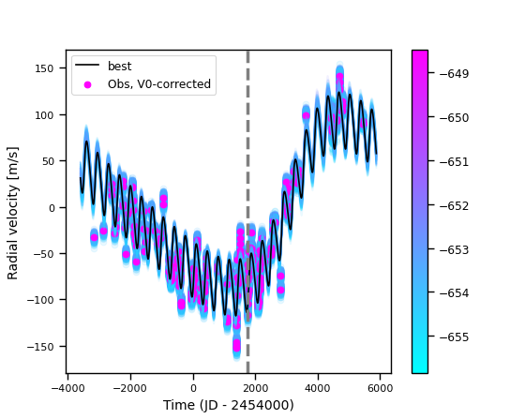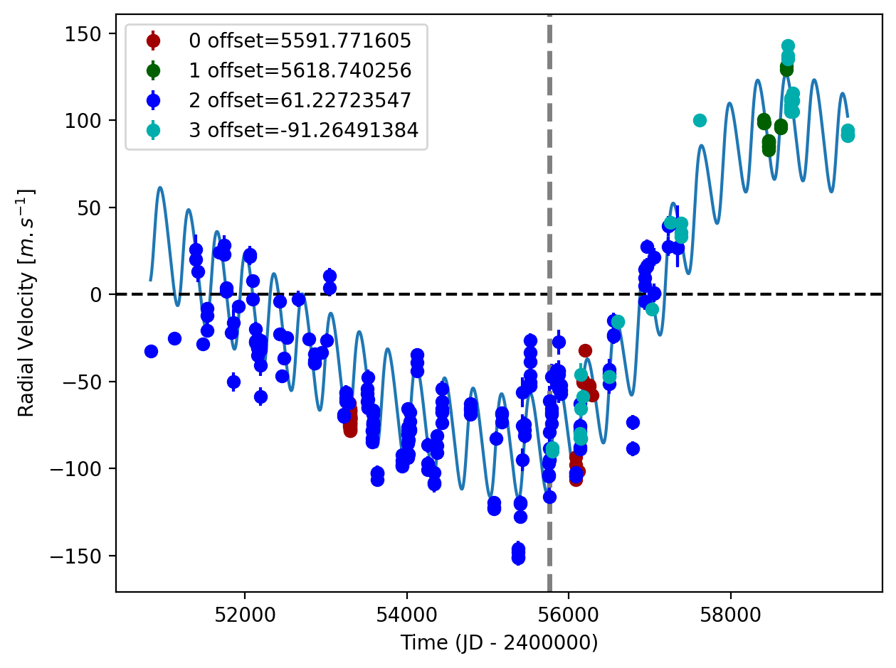

Figure 1: Left: fit of the HD 142A RV with DPASS. Red - H03; green - H15; blue - AAT; cyan - MIKE. The blue curve shows the best fit. Right: fit of the HD 142A RV using MCMC. The black curve shows the best fit. The colorbar corresponds to the log-likelihood of the fits. The gray dotted line indicates the end of the CH survey.

Figure 2: Corner plots of posteriors for the two-planets model MCMC fit of HD142A RV data.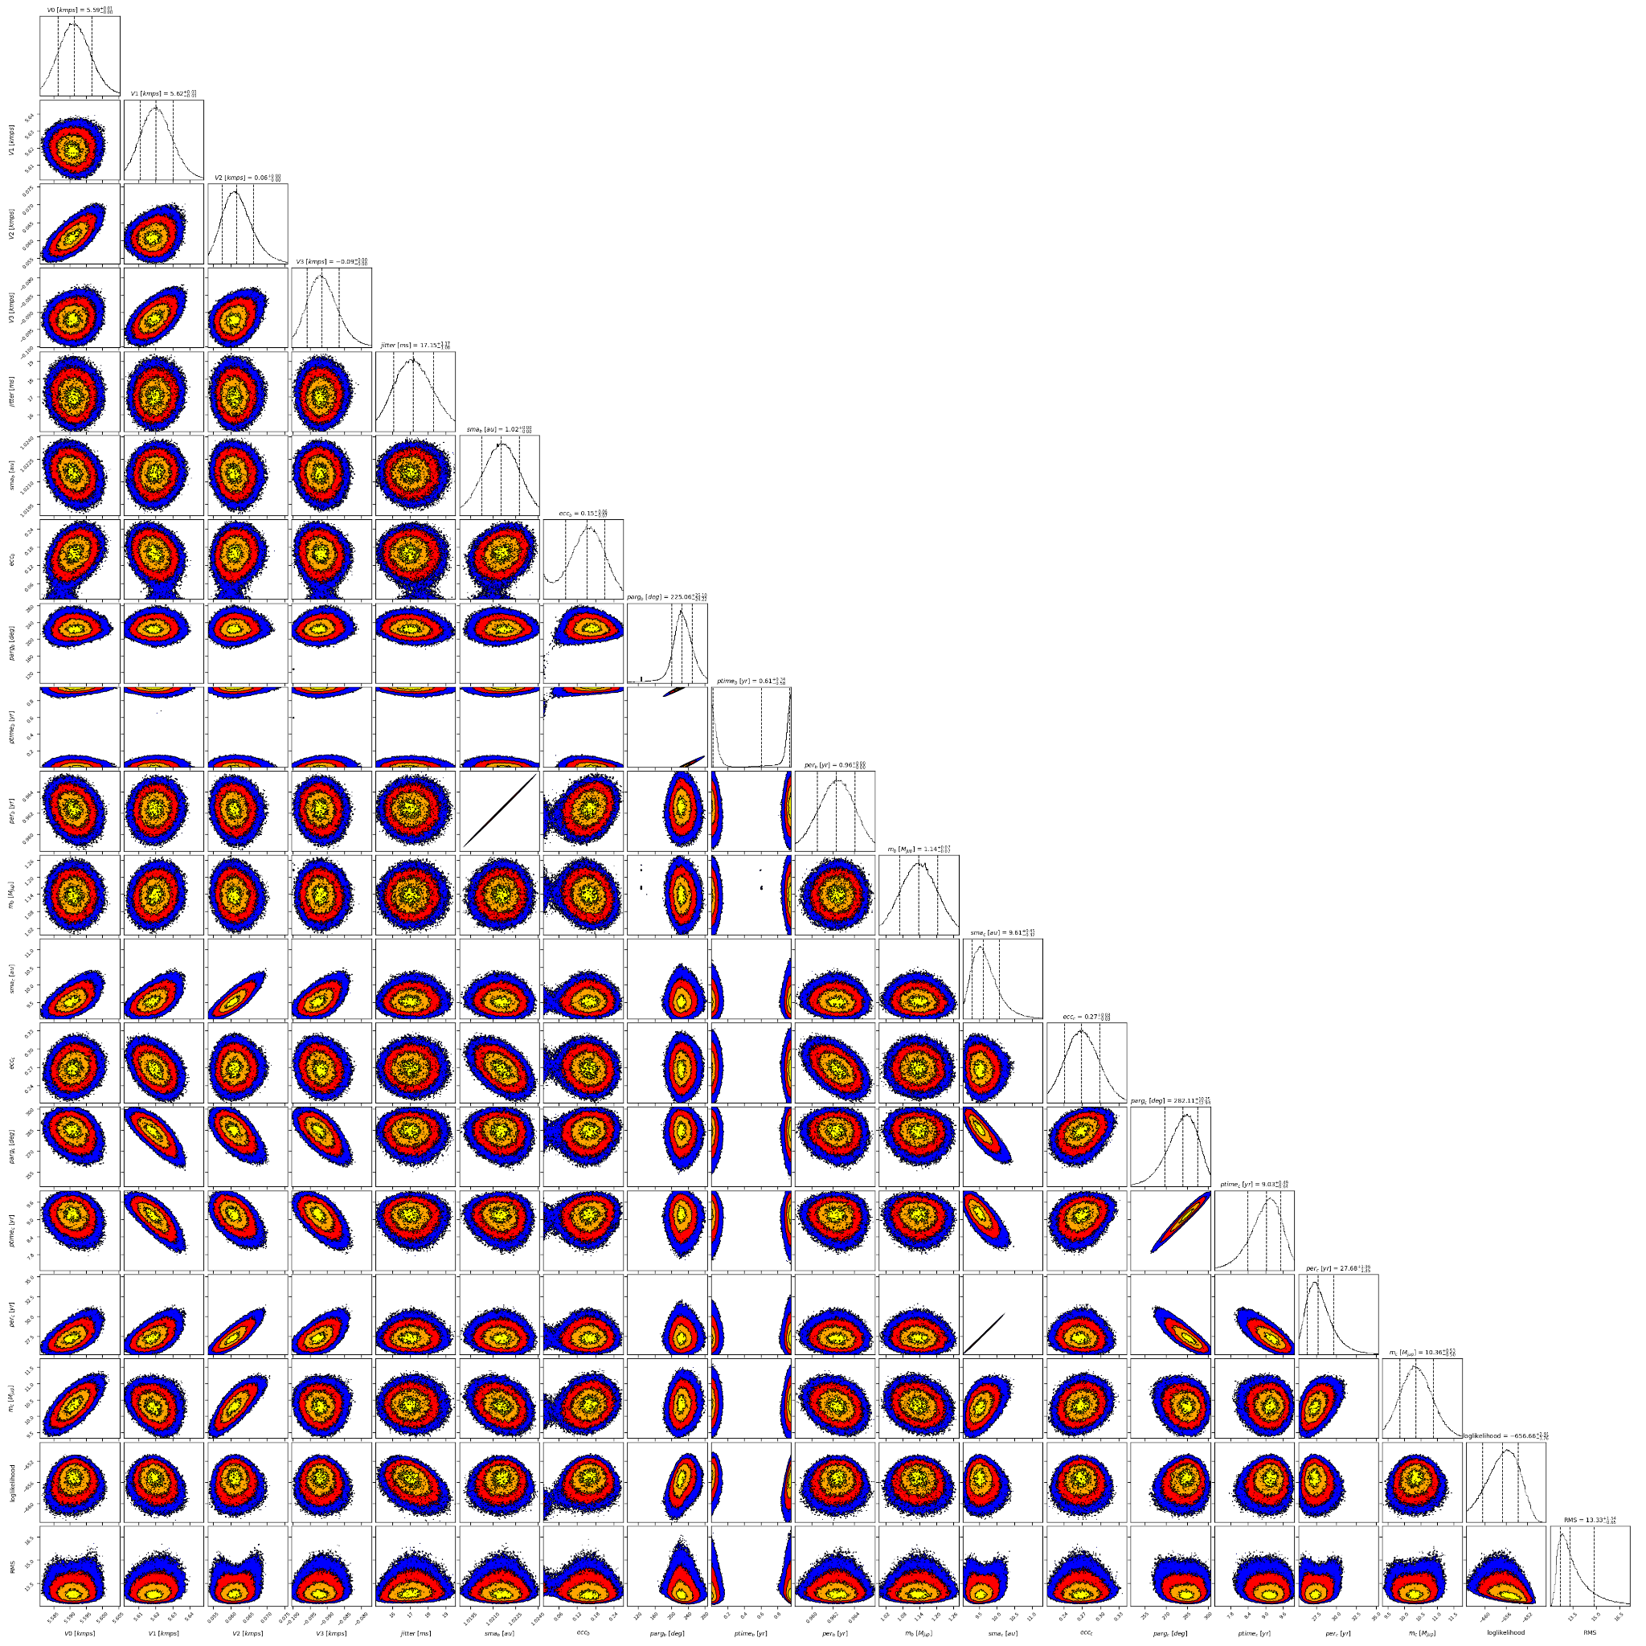

| Parameter | Priors | | Posteriors | | CH survey |
| --- | --- | --- | --- | --- | --- |
|  | DPASS | MCMC | DPASS | MCMC |  |
| *a* (au) | b: [0.1,2]  c: [5,40] | b: [0.5,2]  c: [4,100] | b = 1.02  c = 9.6 | b = 1.02 ± 0.01  c = | b = 1 |
| Msin(i) (MJup) | b: [0.5,1.5]  c: [0,400] | b: [0,10]  c: [1,100] | b = 1.1  c = 10.4 | b =  c = 10.4 ± 0.5 | b = 1.31 |
| Eccentricity | b: [0,0.3]  c: [0,0.95] | b: [0,0.95]  c: [0,0.95] | b = 0.15  c = 0.27 | b =  c = 0.27 ± 0.03 | b = 0.25 |
| Instrumental offsets (km/s) | H03: [-100,100]  H15: [-100,100]  AAT: [-100,100]  MIKE: [-100,100] | H03: [4,6]  H15: [4,6]  AAT: [-1,1]  MIKE: [-1,1] | H03: 5.592  H15: 5.619  AAT: 0.061  MIKE: -0.091 | H03:  H15: 5.62 ± 0.01  AAT:  MIKE: - |  |
| Stellar jitter (m/s) | [0,40] | [0,20] | 16.0 | 17.2 ± 0.1 |  |
| Argument of periastron (°) | b: [0,360]  c: [0,360] | b: [0,360]  c: [0,360] | b = 257  c = 283 | b =  c = |  |
| Phase | b: [0,1]  c: [0,1] | b: [0,1]  c: [0,1] | b = 0.76  c = 0.72 | b = 0.03 – 0.98  c = |  |

Table 1: HD 142A. Summary of priors and posteriors with DPASS and MCMC, compared to the properties reported by CH Survey.

References

1. Tinney, C. et al. Two Extrasolar Planets from the Anglo-Australian Planet Search. *Astrophys. J.* 571, 528-531 (2002).
2. Zarlo, A et al. Imaging radial velocity planets with SPHERE. *Mon. Not. R. Astron. Soc.* 480, 35–48 (2018).
3. Eggenberger, A. et al. The impact of stellar duplicity on planet occurrence and properties. I. Observational results of a VLT/NACO search for stellar companions to 130 nearby stars with and without planets. Astron. Astrophys. 474, 273-291 (2007).
4. Wittenmyer, R. et al. The Anglo-Australian Planet Search. XXII. Two New Multi-Planet Systems. Astron. J. 753, 169 (2012).
5. Feng, F. et al. 3D Selection of 167 Substellar Companions to Nearby Stars. *Astrophys. J. Supp. Ser.* 262, 21 (2022).